*SOURCE 1*

*The* ***Big 3 leaders*** *shown in the cartoon are (left to right) President Wilson of the USA, Clemenceau of France and Prime Minister Lloyd George of Britain. They are standing around a guillotine (an old French execution apparatus) and are focusing on a figure before them.*

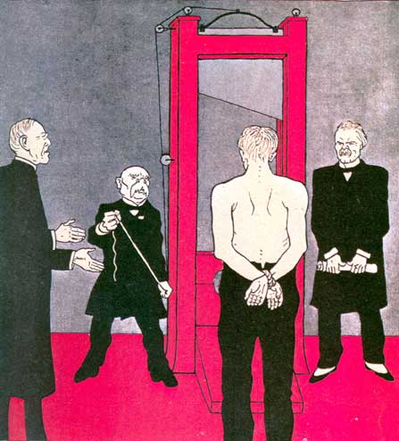

A cartoon published in the German magazine *Simplissimus*, June 1919